**ROS Workspace**

$ mkdir -p ~/catkin_ws/src

$ cd ~/catkin_ws/

$ catkin_make

**Clone repository**

$ cd ~/catkin_ws/src

$ git clone https://github.com/udacity/RoboND-Kinematics-Project.git

**Update all required ros dependencies and permissions**

$ cd ~/catkin_ws

$ rosdep install --from-paths src --ignore-src --rosdistro=kinetic -y

$ cd ~/catkin_ws/src/RoboND-Kinematics-Project/kuka_arm/scripts

$ sudo chmod +x target_spawn.py

$ sudo chmod +x IK_server.py

$ sudo chmod +x safe_spawner.sh

**Build project**

cd ~/catkin_ws

catkin_make

**Add to .bashrc file**

export GAZEBO_MODEL_PATH=~/catkin_ws/src/RoboND-Kinematics-Project/kuka_arm/models

source /home/robond/catkin_ws/devel/setup.bash

**inverse_kinematics.launch file**

demo flag is set to "false” to run new IK_server.py

**Run project**

$ cd ~/catkin_ws/src/RoboND-Kinematics-Project/kuka_arm/scripts

$ ./safe_spawner.sh

$ cd ~/catkin_ws/src/RoboND-Kinematics-Project/kuka_arm/scripts

$ rosrun kuka_arm IK_server.py

**FORWARD KINEMATIC**

Experiment with the forward kinematics environment and get familiar with the robot.

$ roslaunch kuka_arm forward_kinematics.launch

ROS makes it very easy to get the transform between any two given frames with the tf_echo command.

$ rosrun tf tf_echo base_link link_6

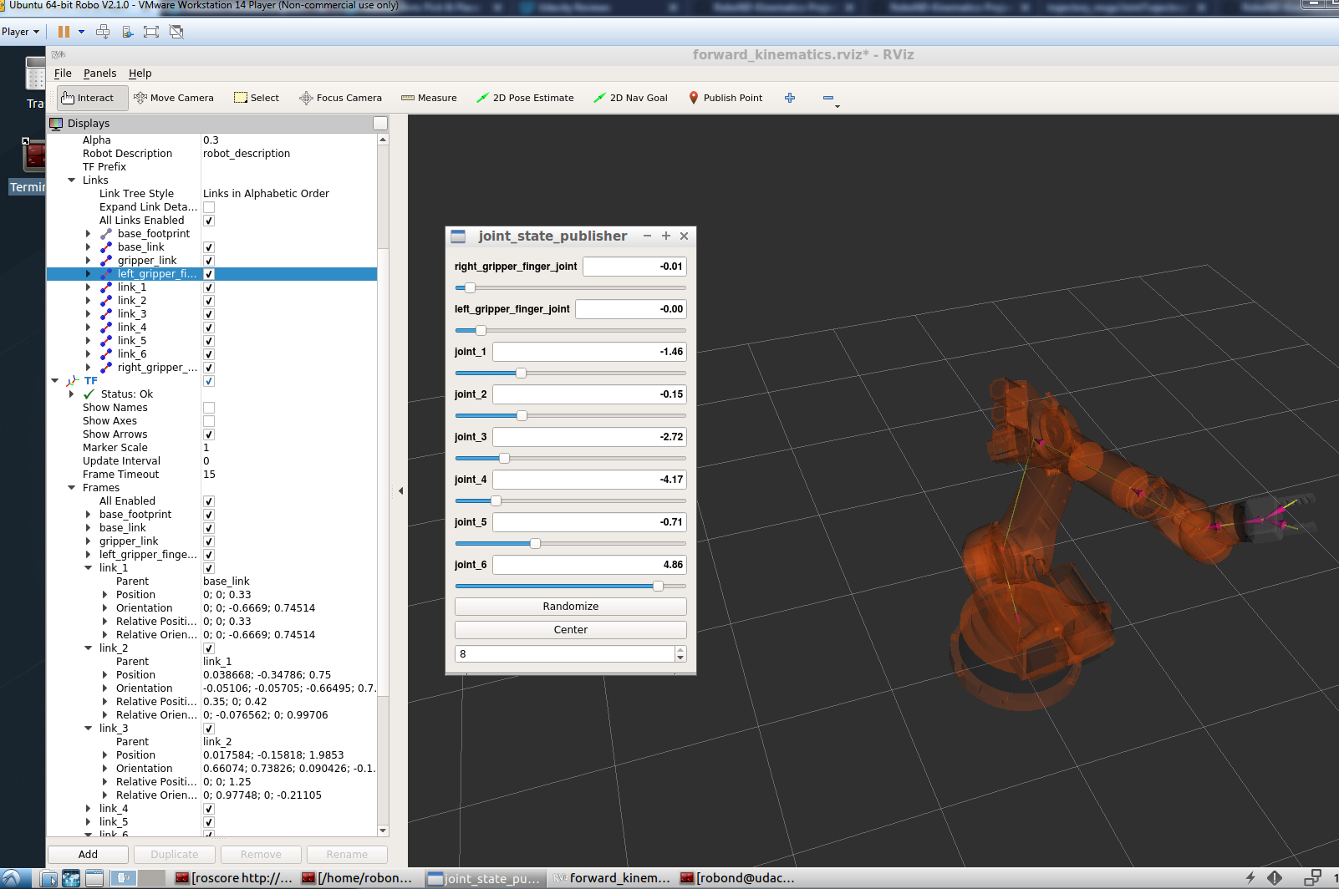

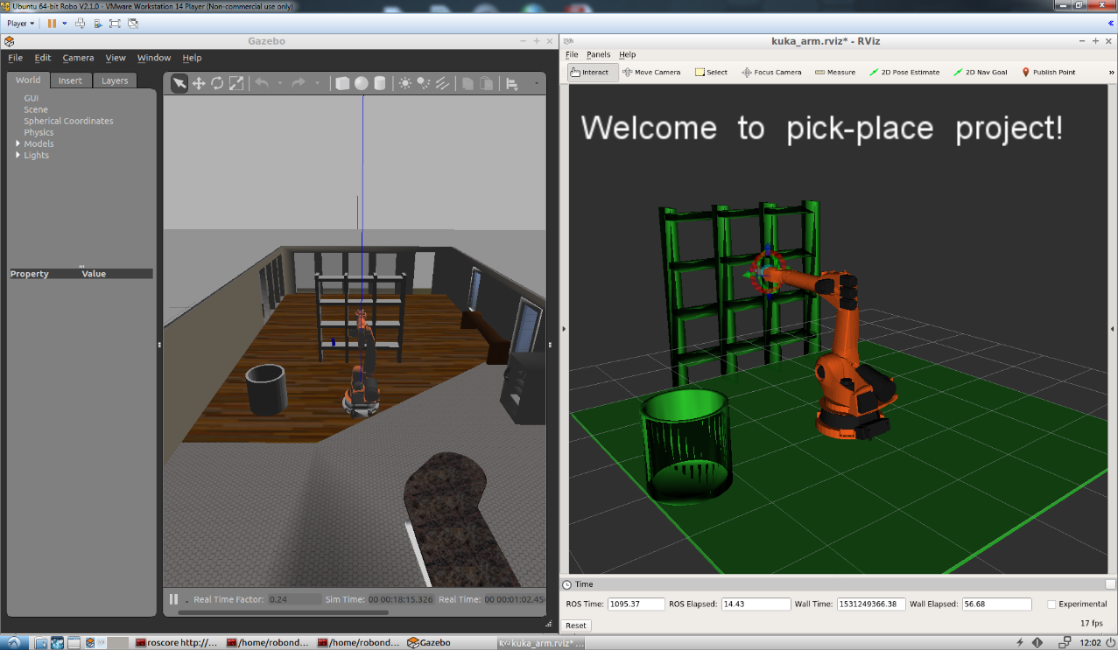

**KR210.urdf.xacro**

All the values for the robot geometry are contained inside urdf file.

It contains static and dynamic friction coefficient for the links, each link origin w.r.t to its local C.S., mass, inertia and also each JOINT type, origin, parent/child LINK, axis, and physical limits.

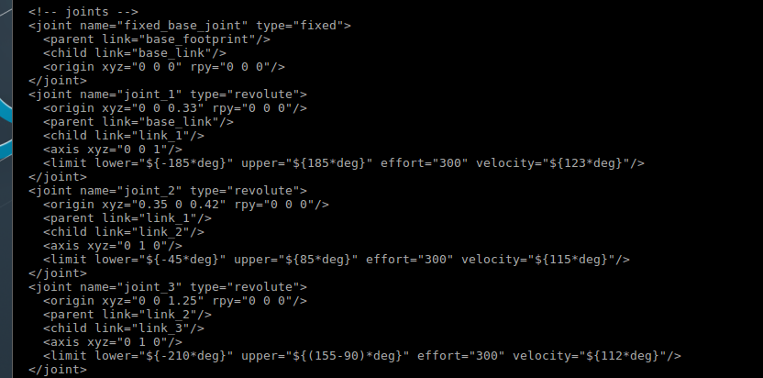

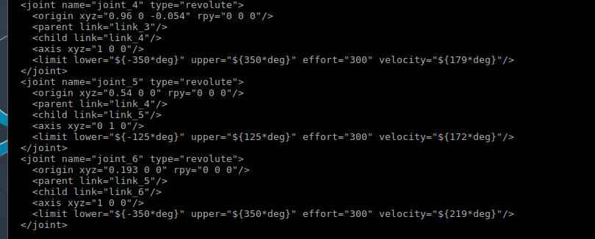

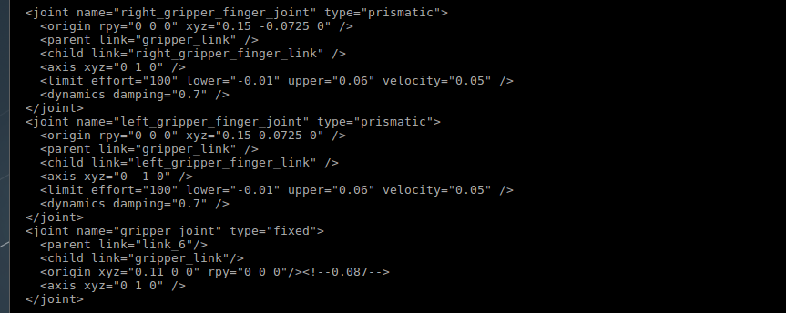

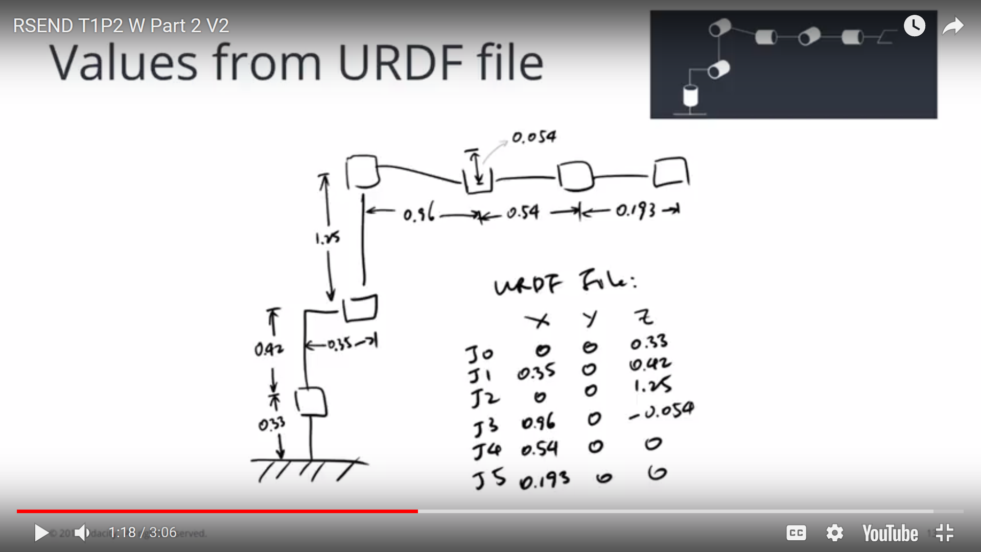

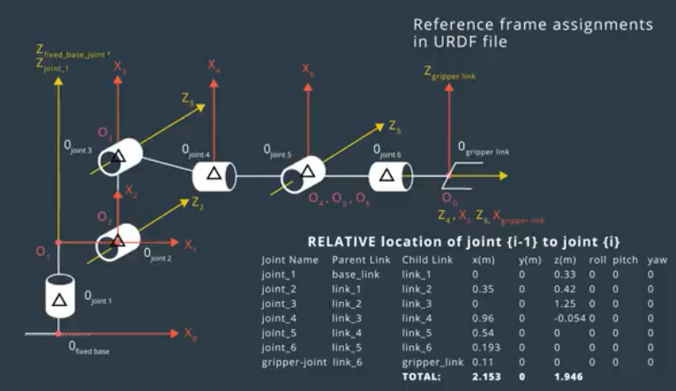

**DH Table**

* alpha = twist angle
* a= link length
* d= link offset
* q= joint angle

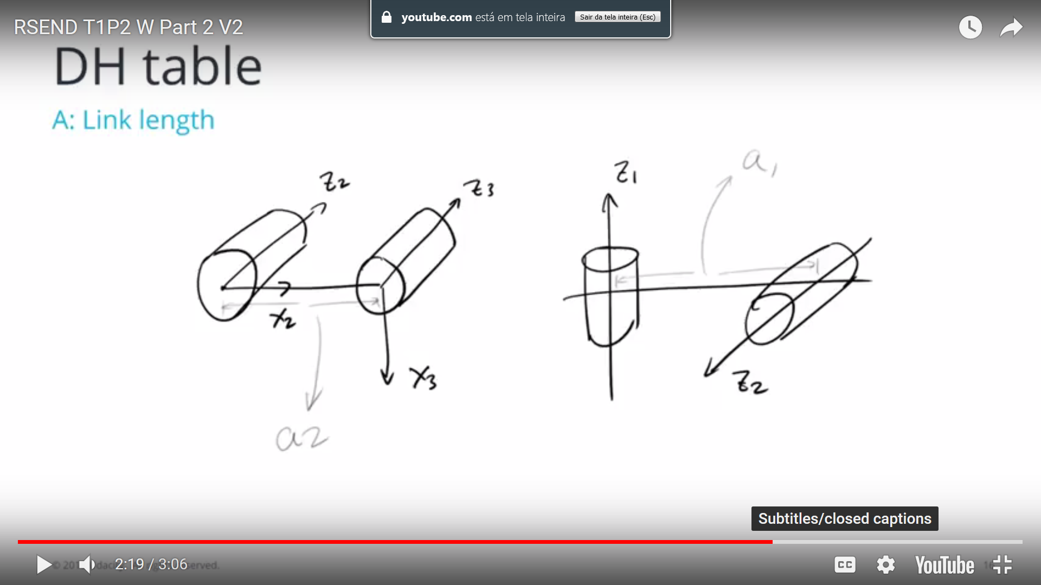 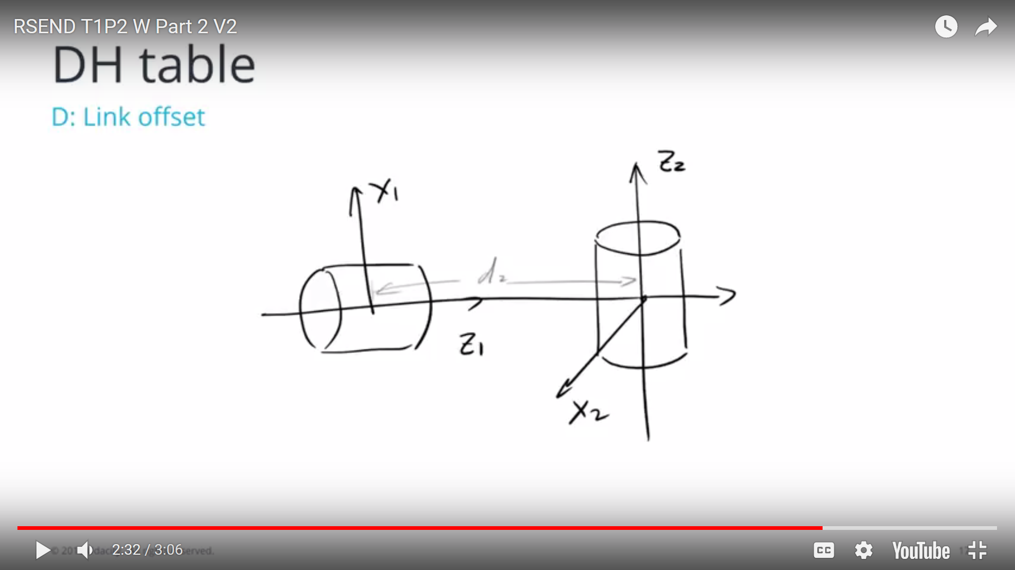

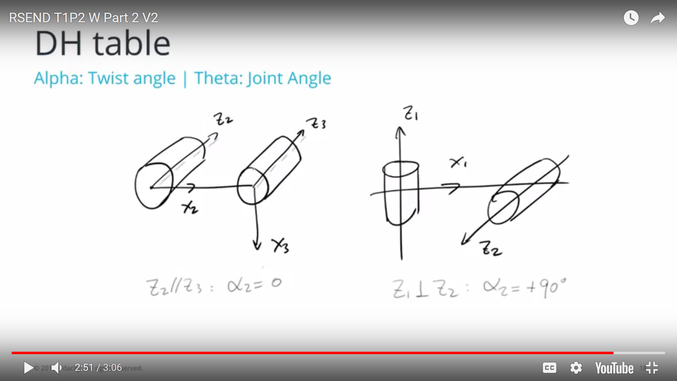 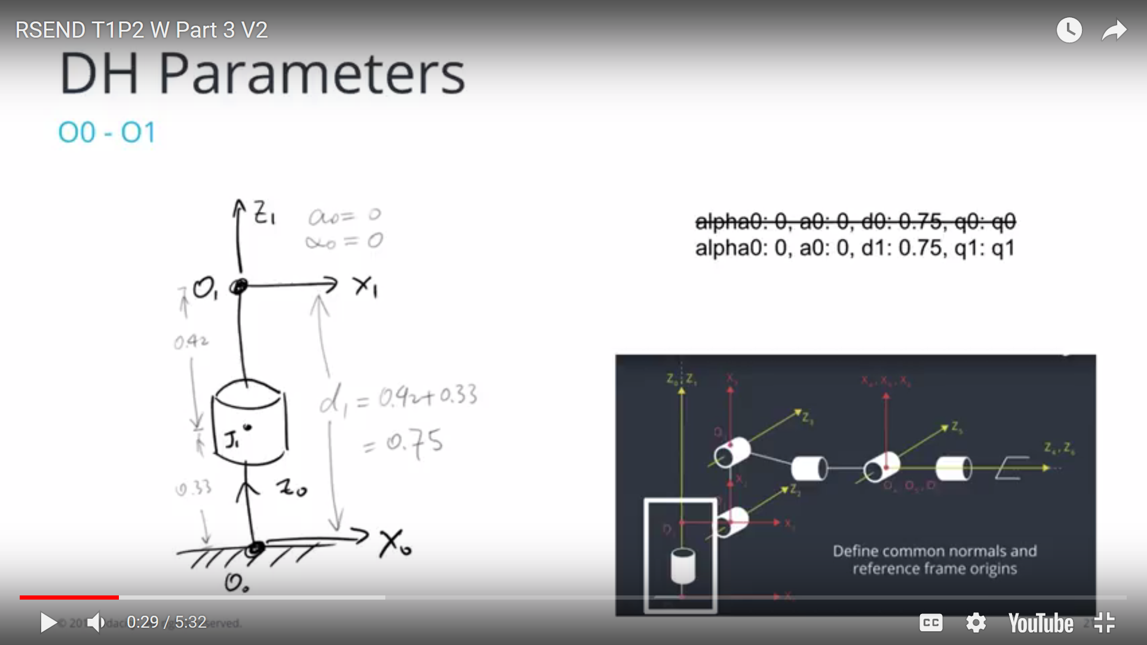

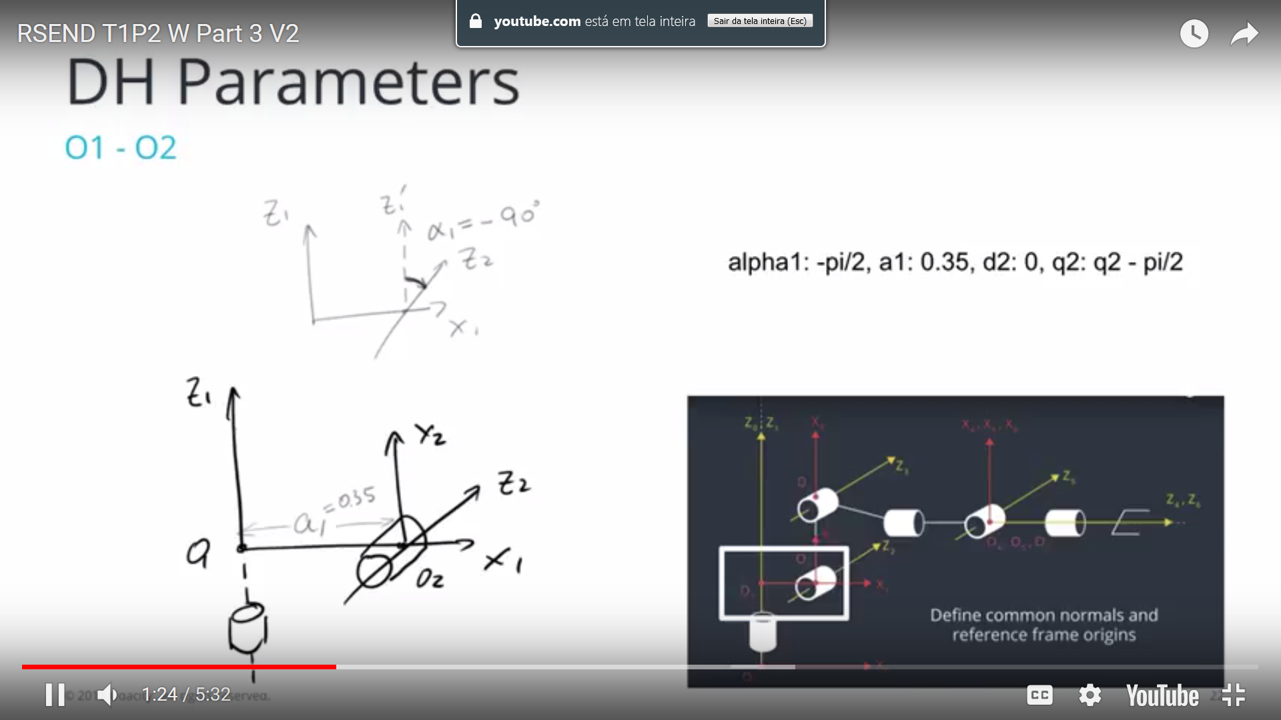 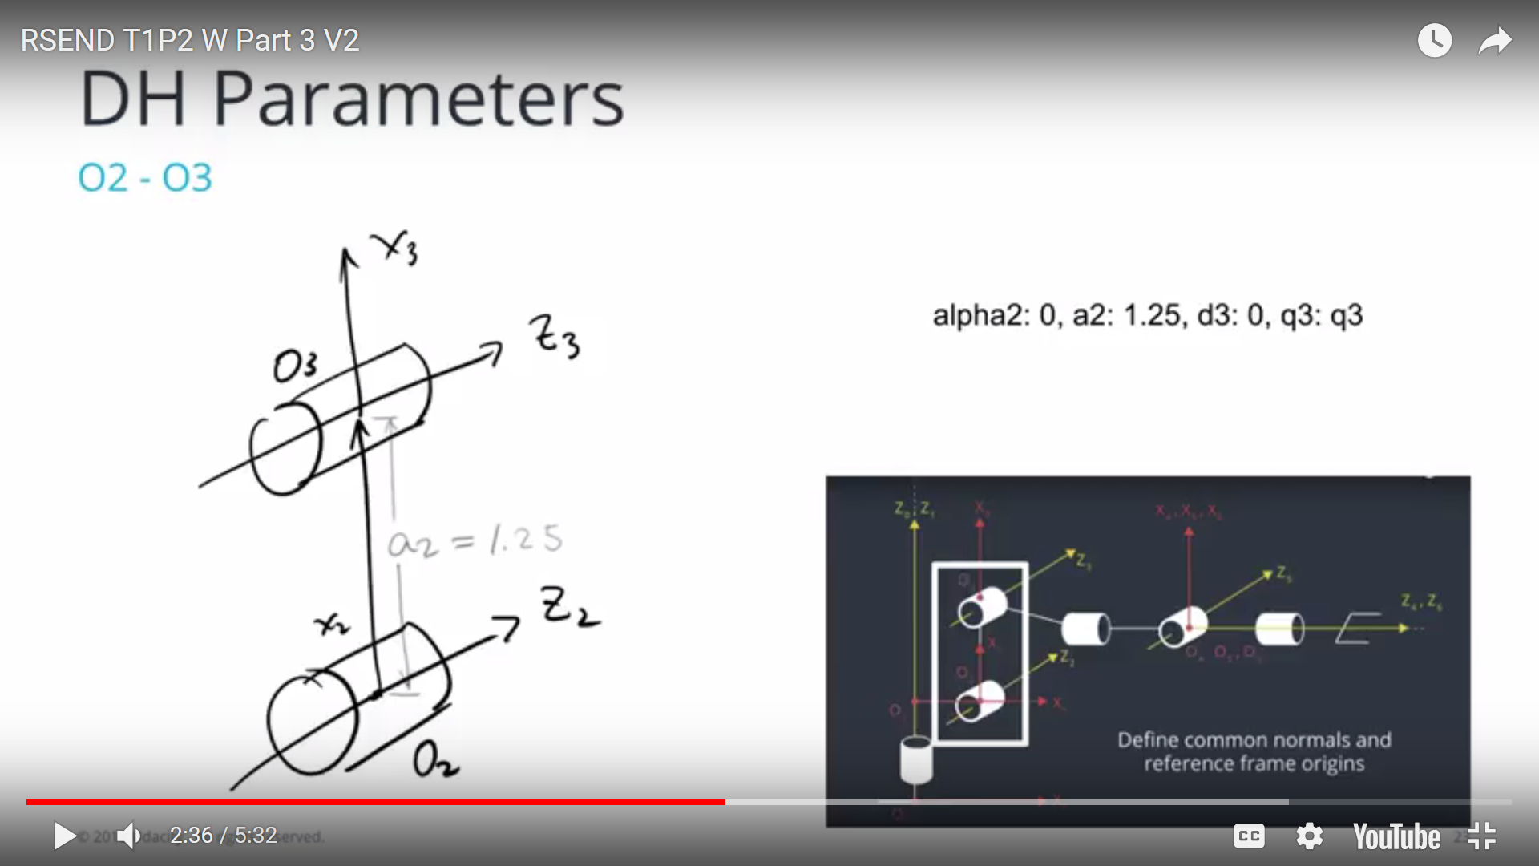

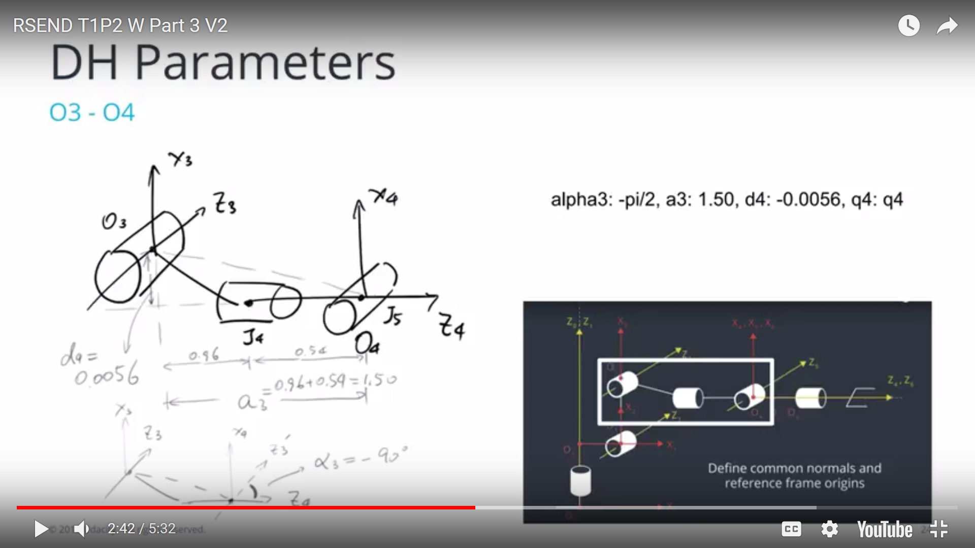 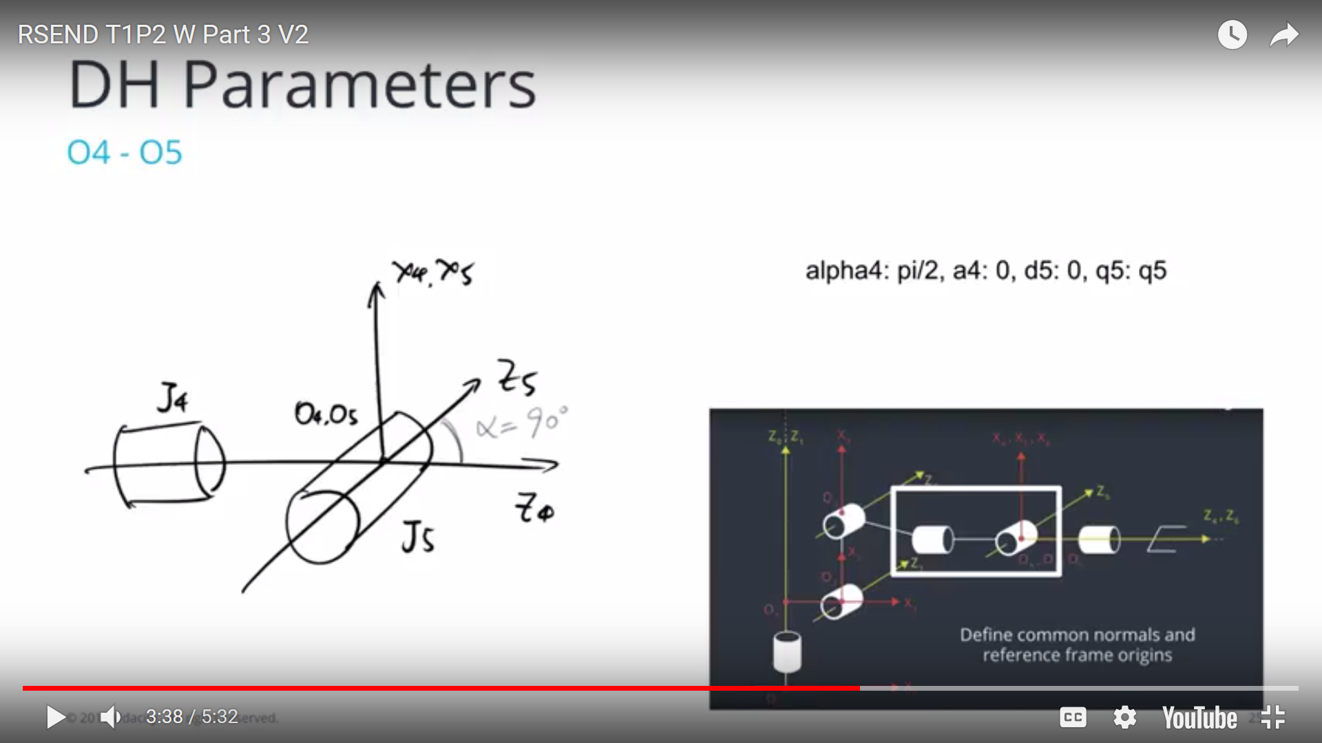

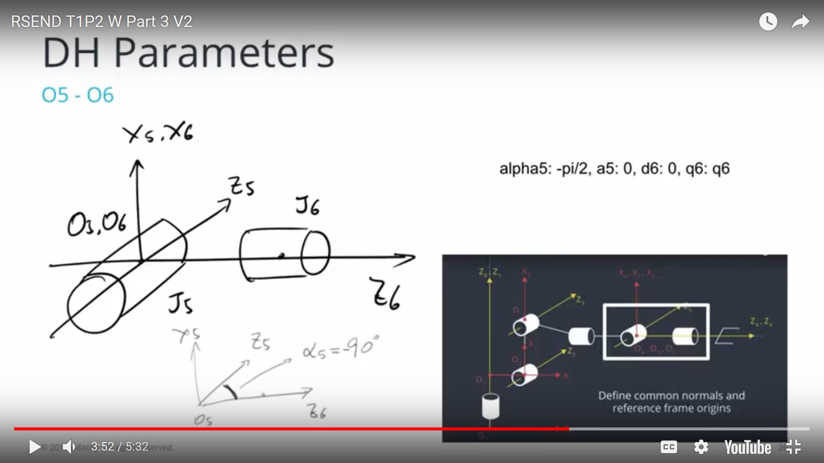 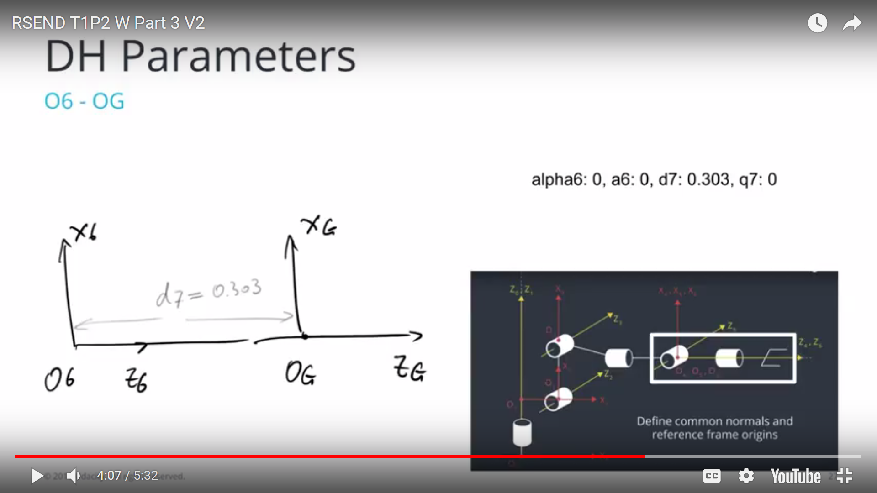

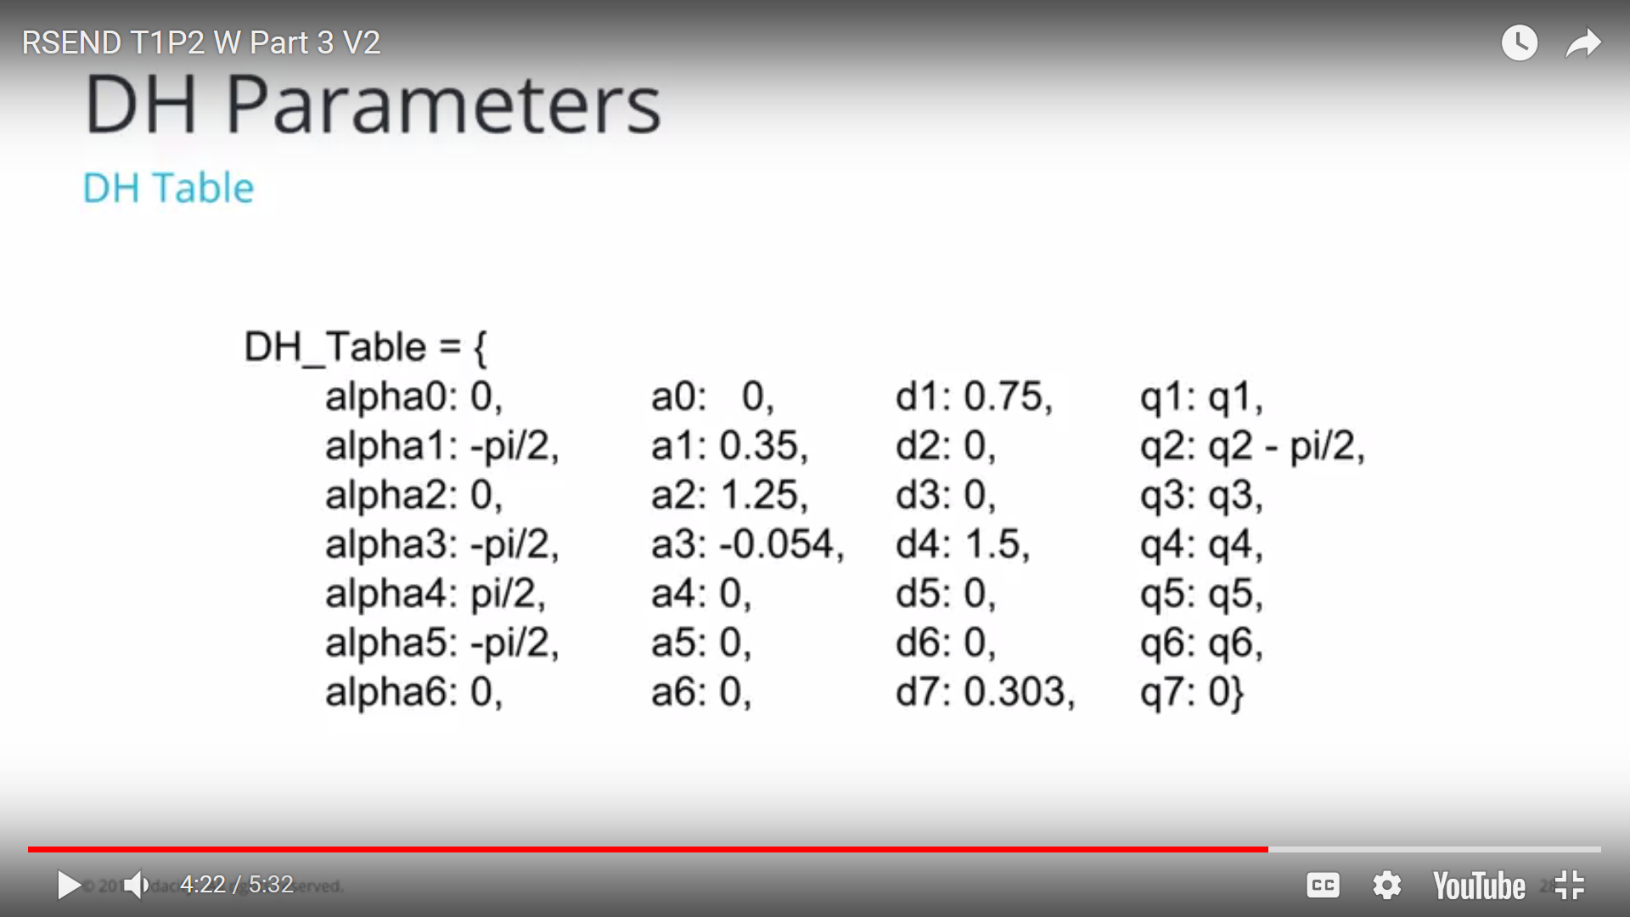

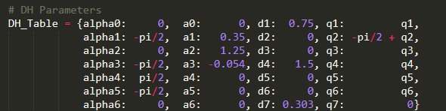

**Matrix for translation and orientation**

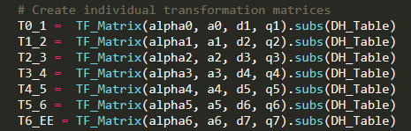



**Inverse position and orientation kinematics**

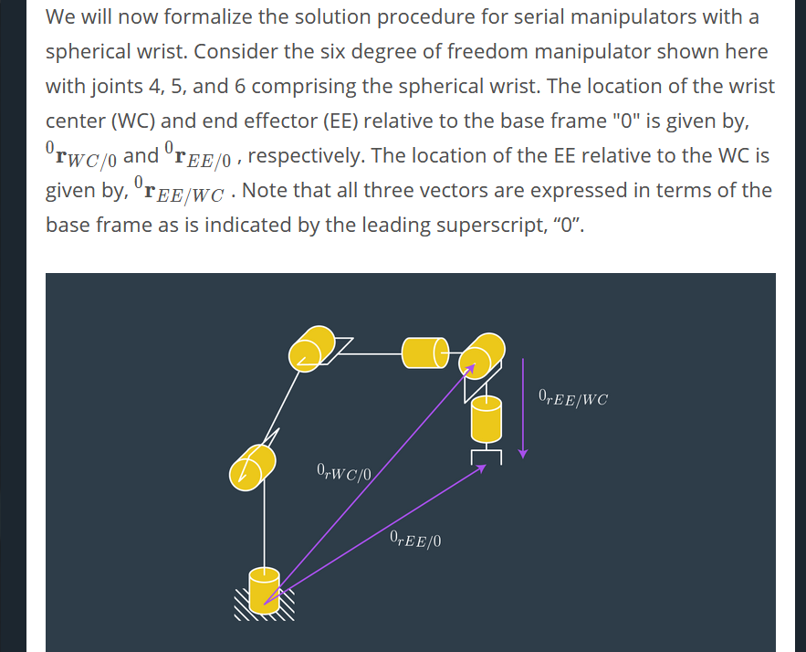

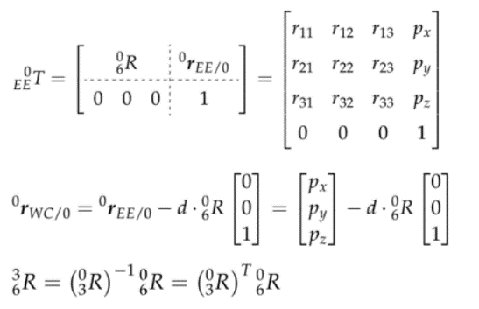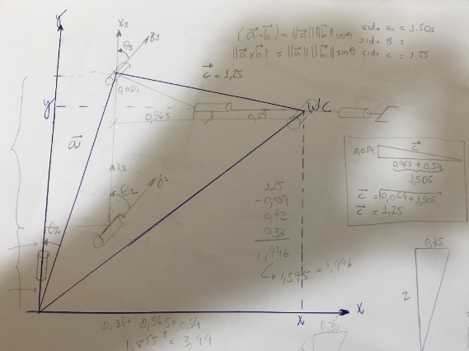

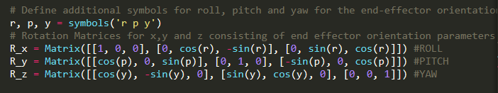

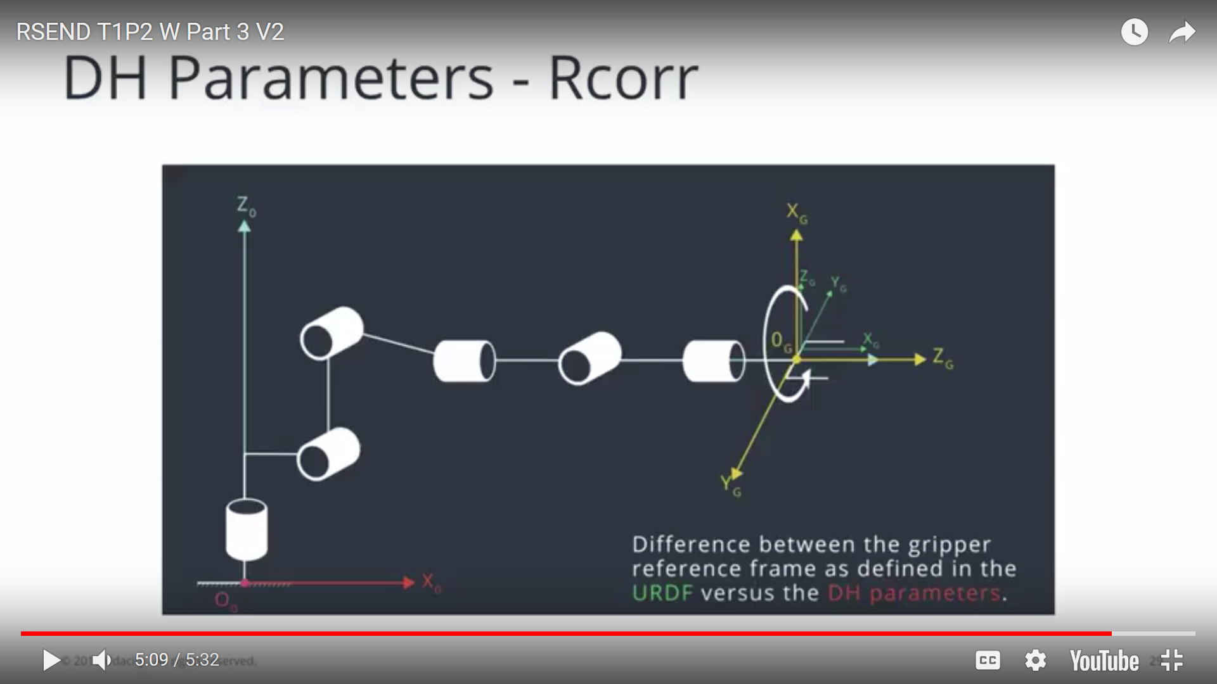

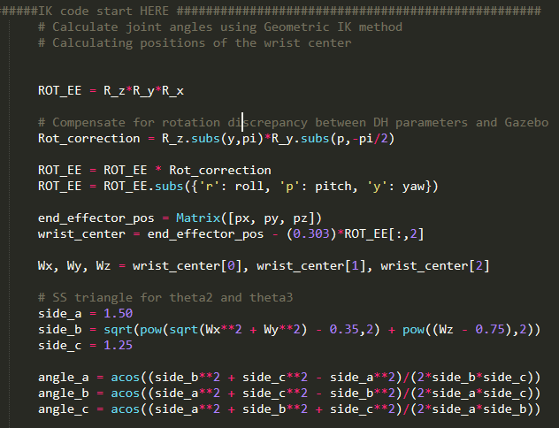

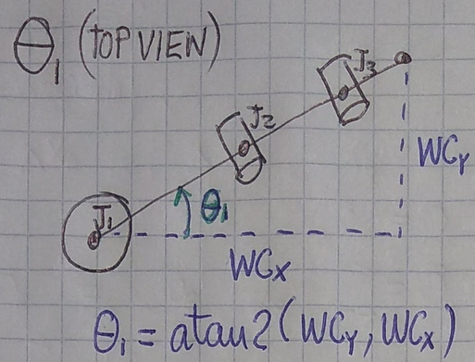

theta1 = atan2(Wy, Wx)

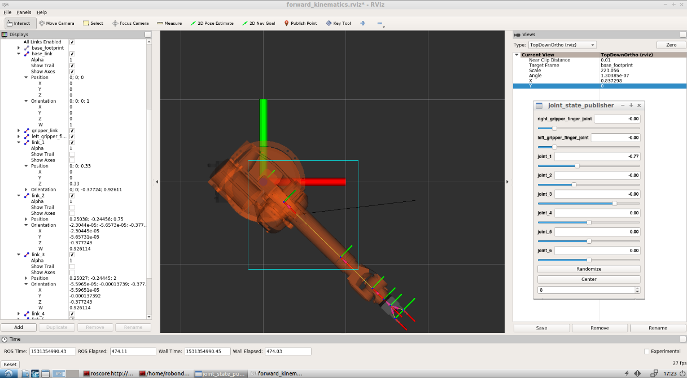

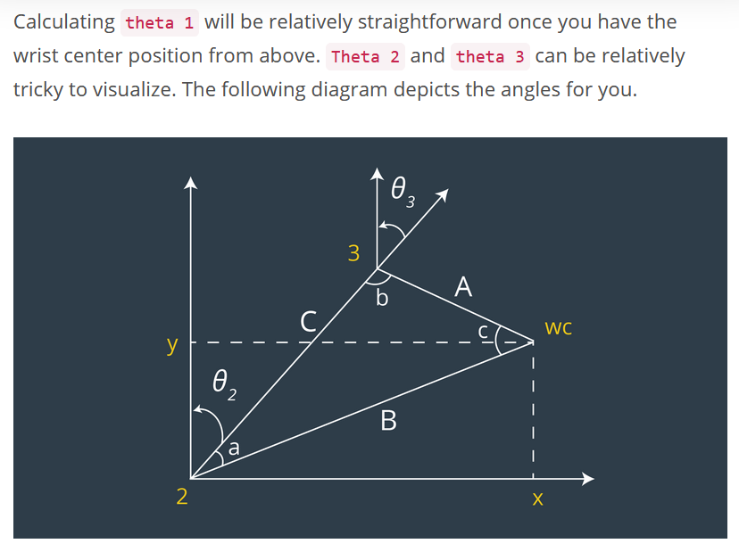

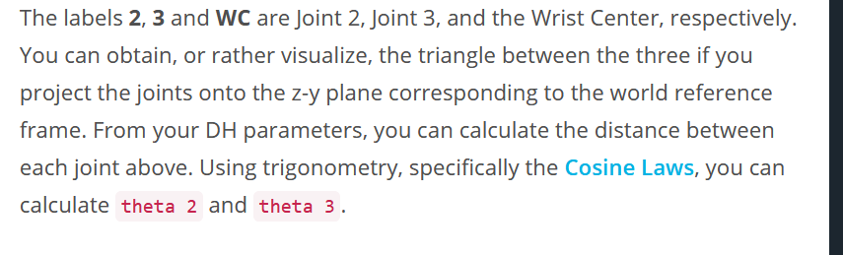

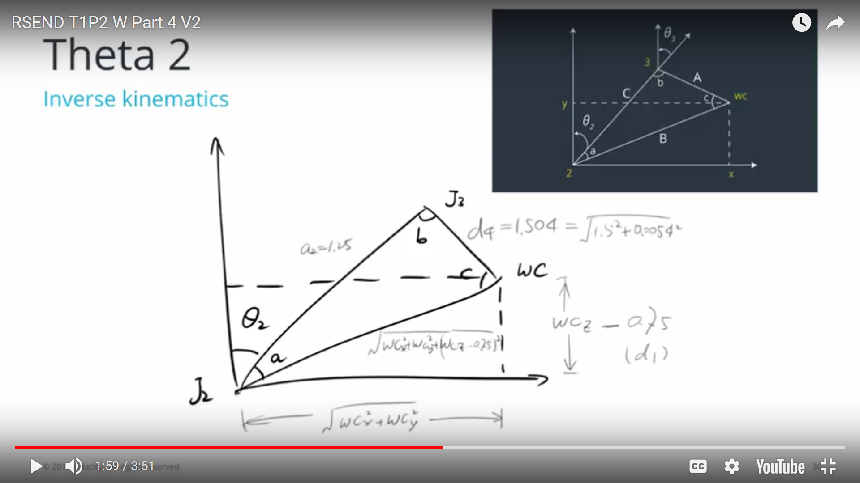

theta2 = pi/2 - angle_a - atan2((Wz - 0.75), sqrt(Wx**2 + Wy**2) - 0.35)

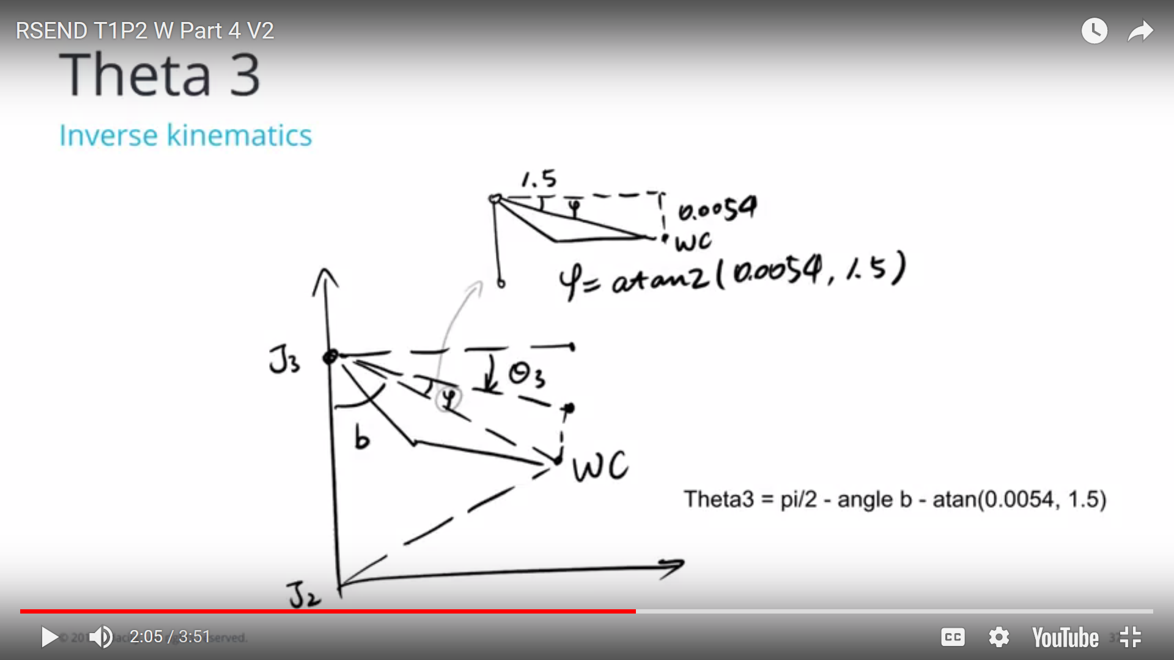

theta3 = pi/2 - angle_b – atan(0.0054, 1.5)

